PREDICTIVE MODELING AND PROFIT OPTIMIZATION
FOR MULTI-CHANNEL RESTAURANT OPERATIONS

Internship Project Report

Submitted by:
Manisha Karmakar

Program:
B. Tech (CSE - AIML)

Institution:
VIT Bhopal University

Internship Organization:
Unified Mentor

Date of Submission:
28-04-26
Dynamic Profit Optimization Engine for Multi-Channel Restaurant Operations

1. Abstract
This project presents a machine learning-based system designed to predict and optimize restaurant profitability across multiple operational channels, including in-store dining, Uber Eats, DoorDash, and self-delivery. The model leverages Random Forest regression to analyze the impact of revenue streams, cost structures, and delivery strategies on net profit. An interactive Streamlit dashboard is developed to enable real-time scenario simulation, allowing users to adjust key parameters such as commission rates, delivery costs, and channel mix. The system transforms static historical data into actionable insights, supporting data-driven decision-making and operational optimization.

2. Introduction
In today’s competitive food service industry, restaurants rely on multiple delivery platforms to increase reach and customer engagement. While platforms such as Uber Eats and DoorDash significantly boost order volume, they introduce high commission costs that impact overall profitability.
Traditional reporting methods fail to capture the dynamic relationship between operational decisions and financial outcomes. This project aims to address this gap by developing a predictive and simulation-based system that enables restaurants to evaluate the financial impact of different strategies before implementation.

3. Objectives
- To develop a predictive model for estimating restaurant profit
- To analyze the effect of delivery platforms on profitability
- To create a scenario-based simulation system
- To optimize channel mix for maximum profit
- To build an interactive dashboard for decision support

4. Dataset Description
The dataset used in this project consists of 1696 records and 30 features, representing operational and financial metrics across multiple restaurant branches.
Key Attributes:
- Revenue data for different channels
- Order volume and average order value (AOV)
- Cost variables such as COGS, OPEX, and commission rate
- Delivery parameters like radius and cost per order
- Net profit for each channel
The dataset enables detailed analysis of how different business factors influence profitability.

5. Methodology
5.1 Data Preprocessing
- Checked for missing values (none found)
- Ensured data consistency and format

5.2 Feature Engineering
New features were created to improve model performance:
- TotalNetProfit = sum of profits across all channels
- ProfitPerOrder = profit divided by total orders
- AggregatorShare = UE_share + DD_share

5.3 Model Development
A Random Forest Regressor was used due to its ability to:
- Handle non-linear relationships
- Capture complex interactions between variables
- Provide high prediction accuracy

5.4 Model Evaluation
The model was evaluated using:
- Mean Absolute Error (MAE)
- Root Mean Squared Error (RMSE)
- R² Score

6. Results
The model achieved the following performance:
- MAE = 869.49
- RMSE = 1177.11
- R² Score = 0.9569
Interpretation:
- High R² indicates strong predictive capability
- Low MAE shows minimal average prediction error
- RMSE confirms stable model performance

7. Exploratory Data Analysis
Exploratory Data Analysis (EDA) was performed to understand the relationships between key variables affecting restaurant profitability. Various visualizations such as histograms, scatter plots, box plots, and correlation heatmaps were used to identify trends, patterns, and dependencies within the dataset.

7.1 Profit Distribution
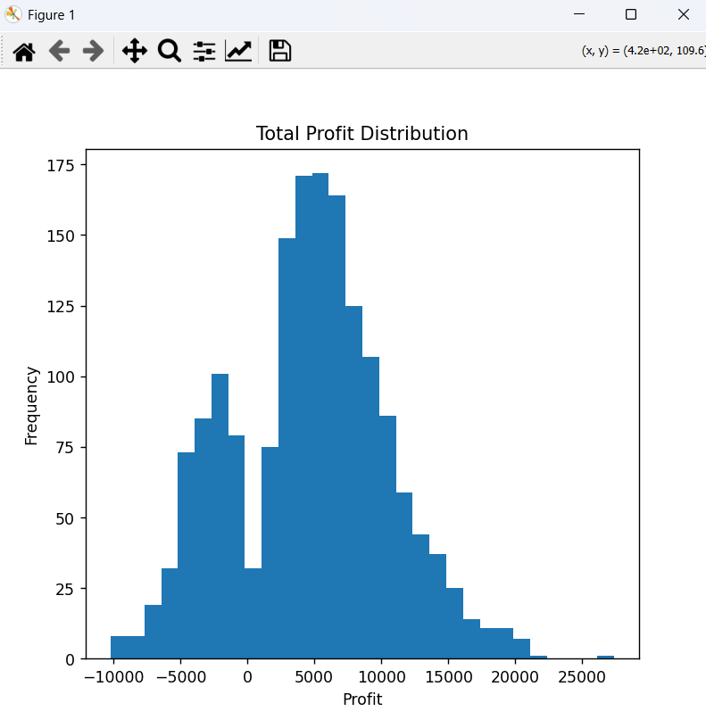
The distribution of total net profit shows that most restaurants operate within a moderate profit range, while a smaller number achieve significantly higher profits. This indicates variability in operational efficiency and strategy effectiveness across different restaurants.
7.2 Profit vs Commission Rate
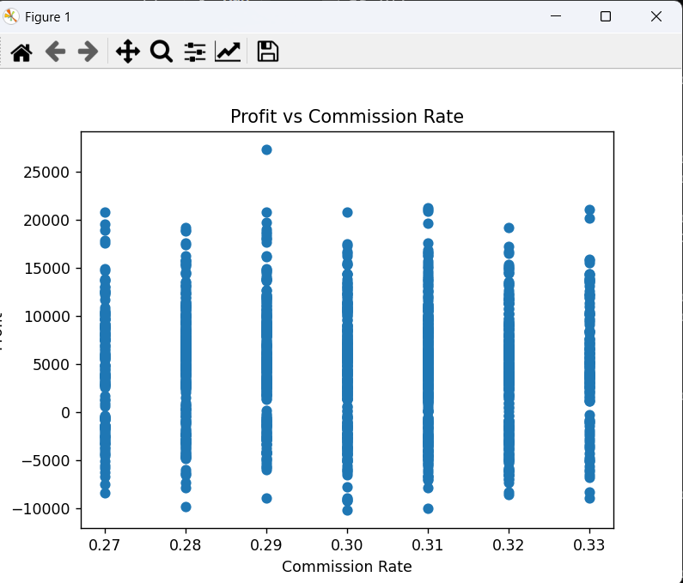
The analysis reveals a clear negative relationship between commission rate and profit. As the commission charged by aggregator platforms increases, the overall profitability decreases. This highlights the significant impact of third-party service costs on business performance.

7.3 Channel Share Analysis
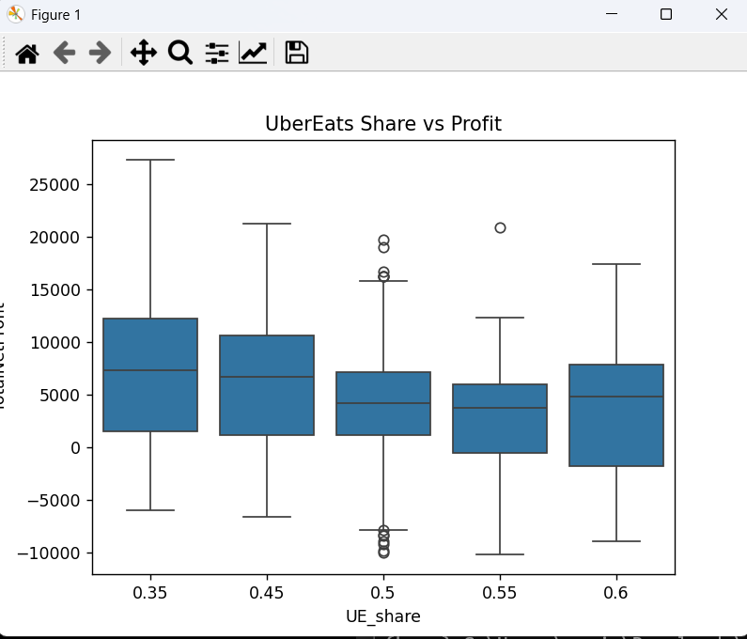
The channel share analysis indicates that restaurants with higher dependency on aggregator platforms (Uber Eats and DoorDash) tend to have reduced profit margins. In contrast, self-delivery and in-store channels provide better control over costs and result in improved profitability.
7.4 Correlation Analysis
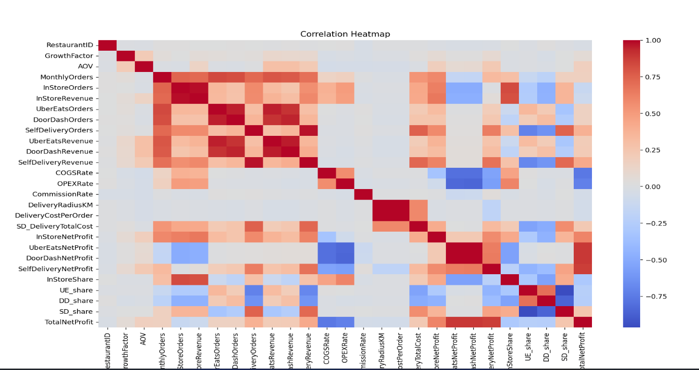
The correlation heatmap highlights strong relationships between key financial and operational variables. Profit is highly influenced by factors such as commission rate, delivery cost, and operational expenses. These relationships help in identifying the most critical variables affecting business outcomes.

Key Findings
- Increasing commission rates significantly reduce profitability
- High dependency on aggregator platforms lowers profit margins
- Self-delivery provides better cost efficiency and higher profit
- Operational cost variables (COGS, OPEX, delivery cost) strongly influence overall performance
- Balanced channel mix leads to optimal profitability

8. Dashboard Implementation
An interactive dashboard was built using Streamlit with the following features:
- Real-time profit prediction
- Adjustable sliders for input parameters
- Visualization of profit sensitivity
- Channel distribution analysis
- Smart recommendations based on input conditions
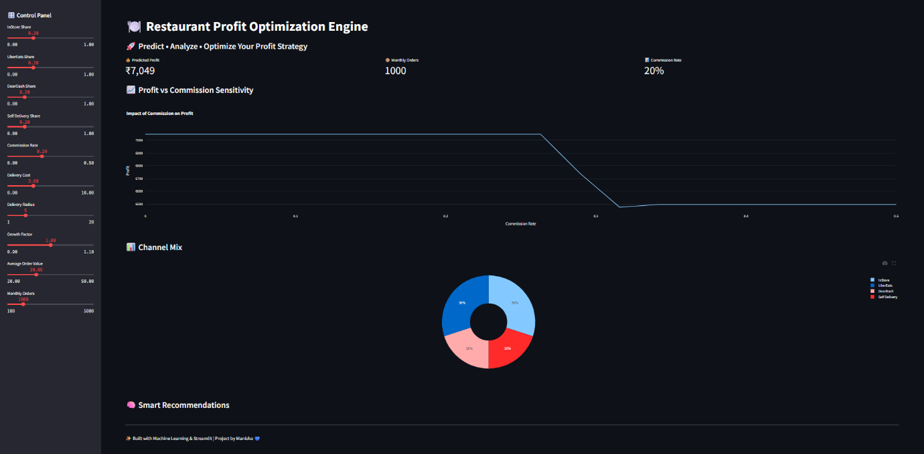
This enhances usability and allows users to perform “what-if” analysis easily.

9. Business Insights
- Balanced channel strategy yields optimal profit
- Excessive reliance on third-party platforms reduces margins
- Moderate self-delivery improves profitability
- Commission rate is a critical factor in profit optimization

10. Conclusion
This project demonstrates how machine learning and interactive analytics can be used to solve real-world business problems. By combining predictive modeling with scenario simulation, the system enables restaurants to make informed decisions that improve financial performance. This project bridges the gap between data analysis and business decision-making through interactive and predictive analytics.

11. Future Scope
- Integration of advanced optimization algorithms
- Real-time data integration
- Expansion to multi-city datasets
- Deployment with user authentication and cloud scaling

